Week06 – Short Paper Assignment – Project Management
SWEN 603 9041
Debashis Jena
University of Maryland Global Campus

Introduction
A software project can be very similar to any other project like construction or mining, yet being a lot different too. Likewise, project management in the software development life cycle has many similarities with other projects and also they have some differences with the process and methodologies. To be successful, every project needs planning upfront. Project planning has been there for more than a century. Henry Gantt considered as the father of project planning and control techniques. The very popular Gantt chart was created by him. He used it for many civil engineering and construction projects. In the 1950s the modern project management got incepted before which the projects were being managed on an ad-hoc basis which used the Gantt chart and some of the informal techniques.
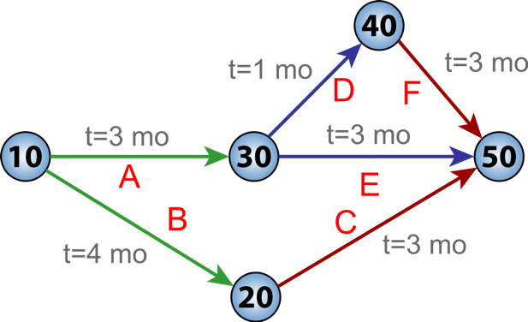
Then comes the PERT (Program Evaluation and Review Technique), which was developed by Booz Allen Hamilton as part of the US Navy’s Polaris missile submarine program. PERT uses mathematical techniques to plan the project with milestones and time.
Figure 1 – PERT Chart for a 7-month project with 5 milestones

Later in the 1960s, the IPMA in Europe and PMI in the USA were founded, which describes many project management practices that are common to most of the projects. PMBOK (Project Management Body of Knowledge) guide is published by PMI which emphasizes the project management guidelines. However, the IT projects have some complexities and a lot of interdependencies which make it very different from other projects. Many of the project management principles and guidelines will be discussed in this document.

Project Management Approaches
Many approaches have been developed for project management in information technology. Before adopting any of these approaches, sufficient thought and careful consideration should be given keeping the cost and timeline insight. Here are some of the popular approaches.
- The traditional approach – A traditional approach goes through the five linear phases of the project management; initiation, planning, and design, execution, monitoring, and closing. In software development, the traditional approach can be followed in the waterfall model, whereas some of the organizations have started adopting RUP as their linear approach.
- PRINCE2 – PRINCE stands for “PRojects IN Controlled Environments”. PRINCE2 is the second edition of PRINCE. This approach follows 7 principles; Continued Business Justification, Learn From Experience, Defined Roles and Responsibilities, Manage by Stages, Manage by Exception, Focus on Products, Tailor to Suit Project Environment. This program management method is different from the traditional method and can be explained in figure 2. In PRINCE2, the processes are each specified with their own inputs and outputs. Each of the processes has a specific goal and certain activities are executed. Since the processes are completely decoupled and independent of each other, it allows for automatic control of any deviations from the plan (Graham, 2010). As can be depicted from figure 2, the method divides the project into smaller stages, enabling efficient control of resources.
Figure 2 The PRINCE2 process model
- PRiSM - Projects integrating Sustainable Methods. This is a project management method that is based on sustainable development methods. It was first created by an American company "GPM Global (Green Project Management)". The goal of this method is to manage projects while integrating environmental sustainability into the process. It considers the five aspects of sustainability; People, Planet, Profit, Process, and Product.
- Critical chain project management (CCPM) – This method is mainly designed to deal with uncertainties inherited in managing a project. In the traditional method, 30% of the lost time is consumed by some of the ineffective techniques like multitasking, in-box delays and lack of prioritization. In CCPM, this method targets to minimize these lost time. As a work breakdown structure is created, this method recommends planning the work in a backward fashion from the completed date and with each task starting as late as possible. This method uses the method and algorithm which is derived from "Theory of Constraints" (TOC).
- Event chain methodology – This method essentially complements the CCPM and is an uncertainty modeling. This method uses a network analysis technique that manages events and relationships between them which may affect project schedules.
- Process-based management – This method of project management has been driven by CMMI (Capability maturity model integration). This method is a documentation heavy process. It has three stages which are Documenting the process, Analyzing process performance, and implementing the improvements. The CMMI was developed by the Software Engineering Institute at Carnegie Mellon University (CMU). Now, the CMMI Institute performs appraisals of the organizations and certifies them different levels ranging from level 1 through 5, based on the processes they follow.
- Agile project management – This method is typically followed in the agile software development process. This method contrasts with the traditional method of project management. The product is split into very small systems and the development is carried out iteratively, taking feedback from the previous iteration. It requires a close association with the customer.
- Extreme project management – This method of management is typically followed in short term projects where the extreme programming or scrum method can be followed.
- Benefits realization management (BRM) – This method can be an addon to other project management techniques. In this method, the outcome of the project is assessed frequently during the project lifecycle. This helps keep the project on track to finish.

Conclusion
Each of the project management methods specified above is meant for different scenarios and different kinds of projects. The project requirements, timelines, budget need to be evaluated thoroughly before adopting any of the above methods. For example, let's consider a small project like triggering a confirmation email when an order is placed. The order placement and fulfillment are currently implemented, however, the confirmation emails are batch sent to the customers. However, the requirement is to make it realtime and send the email as soon as the order is placed and payment is collected. This is going to be a small project and does not need a lot of documentation that may delay the delivery. So for this, a traditional method may not be effective. Rather, an extreme project management method may be followed which implements the project in a short period.

Reference
Graham, Nick. (2010). Prince2 for dummies, second edition. Retrieved from http://library.books24x7.com.ezproxy.umuc.edu/toc.aspx?bookid=49720.
Leach, Lawernce P.. (2000). Critical chain project management. Retrieved from http://library.books24x7.com.ezproxy.umuc.edu/toc.aspx?bookid=1077.

